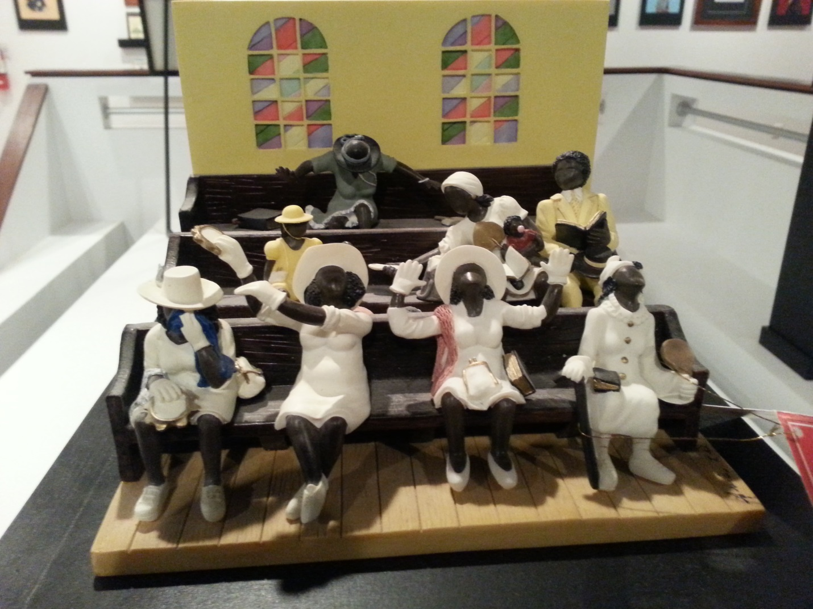

Coming Together
Annie Lee

"The Black Church," a brief history


“The Black Church,” A Brief History

This institution which was the first source of land ownership for slaves in America (with the human character of black people) is viewed as the reason and savior of oppressed African people in the United States.
During the decades of slavery in America, slave associations were a constant source of concern to slave owners. For many members of white society, Black religious meetings symbolized the ultimate threat to white existence. Nevertheless, African slaves established and relied heavily on their churches. Religion offered a means of catharsis... Africans retained their faith in God and found refuge in their churches. However, white society was not always willing to accept the involvement of slaves in Christianity. As one slave recounted "the white folks would come in when the colored people would have prayer meeting, and whip every one of them. Most of them thought that when colored people were praying it was against them”.
Religious exercises of slaves were closely watched to detect plans for escape or insurrection. African-American churches showed an air of militancy in the eyes of white Americans. Insurrections such as Nat Turner's in Virginia, born out of the religious inspiration of slaves, horrified white Americans. Understanding the potential end which could result from the religious experiences of African slaves, many white Americans opposed the participation of Blacks in Christianity. In African-American history, "the church" has long been at the center of Black communities. It has established itself as the greatest source for African American religious enrichment and secular development.
This development is embodied in Christianity, and the term, "the Black Church” presents many details of racial and religious lifestyles unique to Black history. In essence, the term "the Black Church" is a misnomer. It implies that all Black churches share or have shared the same aspirations and strategies for creating cohesive African-American communities. This is not true, and there were numerous differences found among Black communities which were reflected within their community churches. Black communities differed from region to region. They were divided along social lines, composed of persons from different economic levels, and maintained varying political philosophies. Black communities in the inner cities of the United States have traditionally differed from those in rural areas, etc. In The Negro Church in America, the sociologist E. Franklin Frazier noted, "Methodist and Baptist denominations were separate church organizations based upon distinctions of color and what were considered standards of civilized behavior."
Organized politically and spiritually, black churches were not only given to the teachings of Christianity but they were faithfully relied upon to address the specific issues which affected their members. For many African-American Christians, regardless of their denominational differences, Black Churches have always represented their religion, community, and home. Scholars have repeatedly asserted that Black history and Black church history overlap enough to be virtually identical. One of the First known Black churches in America was created before the American Revolution, around 1758. Called the African Baptist or "Bluestone" Church, this house of worship was founded on the William Byrd plantation near the Bluestone River, in Mecklenburg, Virginia. Africans at the time believed that only adult baptism by total immersion was doctrinally correct.
Black people in America also supported the autonomy of their congregation to make decisions independent of larger church body. Other early Black Church milestones included the Baptist and Episcopal denominations. The First African Baptist Church of Savannah, Georgia which began in 1777. This is said to be the oldest Black church in North America. Originally called the First Colored Church the pastoral life of George Leile’s preaching is tied to its beginning.
In 1787, Blacks in Philadelphia organized the Free African Society, the first organized Afro-American society, and Absalom Jones and Richard Allen were elected as overseers. They established contact and created relationships with similar Black groups in other cities. Five years later, the Society began to build a church, which was dedicated on July 17, 1794. The African Church applied for membership in the Episcopal Diocese of Pennsylvania. The end of the Confederacy signaled freedom for millions of southern black slaves and prompted the emancipation of the black church. This started the emergence of the black church as a separate institution.
At the time white southerners still sought to maintain control over African Americans' worship, for both religious and social reasons. Such services typically emphasized the responsibility of the slave to be obedient and provided biblical justification for black bondage. Slaves had no voice in church affairs and were relegated to the rear of the church or the gallery, as spectators rather than full members of the congregation.
Post -Civil War: After emancipation, black churches became virtually the only place for African-Americans to find refuge. Blacks moved away from the "hush-harbors" that they retreated to for solace as slaves. Formally during this time a church separation petition was filed by thirty-eight black members of the predominantly white Fairfield Baptist Church in Northumberland County, Virginia, in 1867. Referring to the new political and social status of African Americans, the petitioners said they wanted to "place ourselves where we could best promote our mutual good" and suggested "a separate church organization as the best possible way. A month later the white members of the church unanimously acceded to the petitioners' request, setting the stage for the creation of the all-black Shiloh Baptist Church.
Once established, Black c=Churches spread rapidly throughout the South; the Baptist churches led in this proliferation. The 1800’s ushered in many millstones that built on the foundation of the Black Church. To mention just a few, 1808 celebrated the founding of Abyssinian Baptist Church in New York City. Black Americans along with a group of Ethiopian merchants were unwilling to accept racially segregated seating of the First Baptist Church of New York City. They withdrew forever their membership and established themselves in a building on Anthony Street (later Worth Street) calling it the Abyssinian Baptist Church. The name was inspired by the nation from which the merchants of Ethiopia had come, Abyssinia.
Other new churches also emerged because of the missionary activities of black ministers. The Reverend Alexander Bettis, a former South Carolina slave, alone organized more than forty Baptist churches between 1865 and his death in 1895.
Services: With the division of congregations came the development of a distinct religious observance combining elements of African ritual, slave emotionalism, southern suffering, and individual eloquence. Working-class Baptist and Methodist church services fused African and European forms of religious expression to produce a unique version of worship that reflected the anguish, pain, and occasional elation of nineteenth-century black life in the United States.
Such services usually involved a devotional prayer provided by a leading member of the church, singing by the congregation and choir, and the minister's sermon. The prayer would request a powerful God to ease the earthly burden of the congregation and would be enhanced by the congregation's response, an expression of agreement with the words "Yes, Lord," "Have mercy, Lord," and "Amen."
After the prayer the congregation typically showed their devotion through song. Even if a formal choir existed, all the members of the congregation would be expected to participate. Occasionally an individual member outside the choir would stand up and lead the house in song. By the turn of the century, most southern black church choirs had assumed the responsibility for presenting the hymns, but the "call and response" tradition continues today.
The third element in a classic black service was the minister's sermon. Building on the long tradition of slave preachers and "exhorters," many ministers employed all the drama and poetry at their command, injecting vivid imagery and analogy into their biblical accounts conveying understanding of the rewards of righteousness and the wages of sin. Not every minister was capable of eliciting such a response. But those ministers who did avoid "emotion without substance" and stirred their congregations to strive for a more profound faith and more righteous way of living in a world of adversity provided spiritual guidance for a people whose faith and capacity for forgiveness was tested daily. For these people the black church was indeed "a rock in a weary land.
Nineteenth-century black churches ministered to the needs of the soul and served a host of secular functions, which placed them squarely in the center of black social life. Church buildings doubled as community meeting centers and schools until permanent structures could be built, and during Reconstruction they served as political halls. The black church provided shelter for visitors as well as temporary community theaters and concert halls where religious and secular plays and programs were presented.
In a blurring of spiritual and social functions church members provided care for the sick or incapacitated and financial assistance to students bound for college. They also sponsored virtually all the many fraternal lodges that emerged in the nineteenth-century South. As racially motivated violence and terrorism ran rampant across the country, Black churches were staunch in their resistance.
In 1886 blacks organized the National Baptist Convention, in a continued attempt to reduce the influence of white national bodies among blacks. As the number of Baptist churches grew, they met regularly in regional conventions that then evolved into statewide and national organizations. By 1895 the various Baptist associations had formed the National Baptist Convention of America, representing 3 million African American Baptists, primarily in the South.
The African Methodist Episcopal (AME) Church emerged as the second-largest, post Civil War black denomination. Because of its independence, the AME Church had always been viewed with suspicion in the antebellum South, having been forced out of South Carolina following the Denmark Vesey conspiracy of 1822. The church was reorganized in South Carolina in 1865 by Bishop Daniel Payne and grew to forty-four thousand members by 1877. Similar growth in other southern states gave the AME Church by 1880 a national membership of four hundred thousand its followers were for the first time concentrated in the South.
Other denominations completed the spectrum of black church organization in the South. The Colored Methodist Episcopal (now Christian Methodist Episcopal) Church, which grew from the black parishioners who withdrew in 1866 from the predominantly white Methodist Episcopal Church, and the African Methodist Episcopal Zion Church each claimed two hundred thousand members by 1880.
In 1895, a meeting attended by more than 2000 clergy was held in Atlanta, Georgia. The three largest conventions of the day: the Baptist Foreign Missionary Convention, the American National Baptist Convention and the National Baptist Educational Convention merged to form the National Baptist Convention of the United States of America. This brought both northern and southern black Baptist churches together. Among the delegates was Rev. A.D. Williams, pastor of the Ebenezer Baptist Church and grandfather of the Rev. Martin Luther King, Jr.
However the more involved Black Churches became in sparring against the racial intolerance and violence targeted against them, the more the churches and their members were punished. Within the church the Presbyterians and Episcopalians also saw the division of their memberships into white and black denominations, with each of the two black churches having some one hundred thousand members by 1900.
In 1908, The Christian Index published the "Colored Methodist Bishops' Appeal to White America-1908." In their statement, church leaders responded to the surge of mob violence and lynching occurring across the country, denouncing terrorism waged against Black persons and imploring the country to suppress the spread of anti-Black violence. As anti-Black terrorism proliferated into the twentieth century, Black churches grew increasingly vehement in their calls for castigation of racial violence. Also on September 15, 1915, the National Baptist Convention of America was formed.
Between World War I and World War II, the black church continued to be not only an arena of social and political life for the leaders of blacks; it had a political meaning for the masses. Although they were denied the right to vote in the American community, within their churches, especially the Methodist Churches, they could vote and engage in electing their officers. The election of bishops and other officers and representatives to conventions has been a serious activity for the masses of blacks.
Almost a century ago the Black church was an organizational site for social and political activities, centers for economic development and growth. As microcosms of the larger society, Black churches provided an environment free of oppression and racism for African-Americans. In black churches, African-Americans were consistently exposed to social, political, and economic opportunities which could be sought and had by all members equally. The representational structure of African-American churches confirmed Black preachers as both religious and community leaders. The sermons of many Black preachers expounded messages of Christianity analogized to the daily experiences of African-Americans. Thematic expressions of overcoming oppression and "lifting while climbing," were first articulated in church sermons.
Civil Right Era: During the Civil Rights era, Black churches were well established social and political power bases for African-Americans. Their enormous presence naturally, sanctioned them with the political power to lead Black people in the movement for civil rights. Some churches and their organizations were completely opposed to any involvement in the political struggle for civil rights. Others chose to participate and did so passionately, organizing by rallies, protests, and marches, while teaching Christianity and community involvement.
In the late 1940’s, 50’s, and 60’s, the Black Church functioned as the institutional center for Black mobilization. They provided an organizational base and meeting place, for African-Americans to strategize their moves in the ongoing fight against racial segregation and oppression. As Black Churches became the epicenter of the social and political struggles for Black equality, they increasingly became targets for racially motivated violence. An extensive assault on members of a Black community took place by burning a Black Church.
The bombing and burning of Black churches during this time translated into an attack upon the core of civil rights activism, as well as upon the larger Black religious community. The most infamous example of racist American church destruction occurred on September 15, 1963. When the Sixteenth Street Baptist Church in Birmingham, Alabama, was fire bombed, the explosion was felt by the entire Black community. Four children killed in the attack, several others injured, and a community's sense of security within their church was forever traumatized.
This act signified the depths to which racial hatred could fall. Like many other churches bombed before and after, the Sixteenth Street Baptist Church was a Black Church. Even though the Ku Klux Klan (KKK) was implicated in this crime, members of the KKK were not the only ones responsible for similar acts of terror throughout the country. Unfortunately, this was not an isolated incident. These, racially motivated arsons did not destroy the souls of Black communities. In 1988, the National Missionary Baptist Convention of America was formed.
In the 1990 C. Eric Lincoln book The Black Church in the African American Experience with Lawrence H. Mamiya. They described the, "seven major historic black denominations: the African Methodist Episcopal (AME) Church; the African Methodist Episcopal Zion (AMEZ) Church; the Christian Methodist Episcopal (CME) Church; the National Baptist Convention, USA., Incorporated (NBC); the National Baptist Convention of America, Unincorporated (NBCA); the Progressive National Baptist Convention (PNBC); and the Church of God in Christ (COGIC)," as comprising "The Black Church."
In the Twenty-first century, the Convention movement of the African American Baptist Church has undergone several changes, the individual organizations remain important to African American religious life. The Black Church is also at a crossroads dude to 'WhiteFlight," gentrification and systemic capitalism. The Black Church has historically been a source of hope and strength for the African American community.
Reference:
The Center for African American Ministries and Black Church Studies
5460 South University Avenue
Chicago, IL 60615,
V: 773-947-6300
An Encyclopedia of African American Christian Heritage
by Marvin Andrew McMickle
Judson Press, Copyright 2002
ISBN 0-817014-02-0

